1. Introduction
In the mid-1700s, a German schoolteacher named Gottlieb Mittelberger boarded a ship bound for the colony of Pennsylvania, in far-off North America. Mittelberger had borrowed the cost of his passage by signing on as an indentured servant. He would have to settle his debt by working for several years for the master who bought his services.
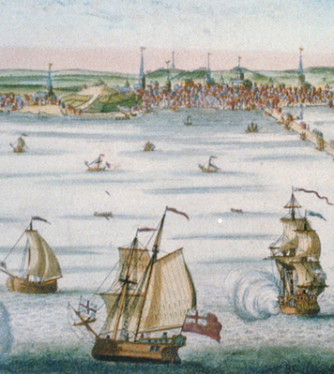
The voyage across the Atlantic was horrible. Most passengers suffered from illness and hunger. “The people are packed densely,” Mittelberger wrote, “like herrings so to say, in the large sea vessels. One person receives a place of scarcely 2 feet width and 6 feet length . . . There is on board these ships terrible misery, stench, fumes, horror, vomiting, many kinds of seasickness, fever, dysentery, headache, heat, constipation, boils, scurvy, cancer, mouth-rot, and the like, all of which come from old and sharply salted food and meat, also from very bad and foul water.”
When the nightmarish voyage ended, Mittelberger had to stay on board until his service was bought. Most indentured servants had to work for their masters for three to six years, but commitments varied according to the servants' age and strength. As Mittelberger noted, “young people, from 10 to 15 years, must serve till they are 21 years old.”
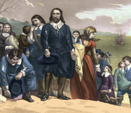
Why were people willing to go through such hardships to come to the colonies? Many colonists came to North America for the chance to own land and start a new life. Others were seeking freedom to practice their religion. There were also some who did not have a choice. A number of convicts (people in jail) were forced to go to North America to work off their debts as indentured servants. Millions of Africans were kidnapped from their homelands and brought to the colonies as slaves.
In this chapter, you will learn about the people who settled the English colonies. You will read in detail about 8 of the 13 colonies. As you do, pay attention to similarities and differences among the colonies in such areas as geography, economy, religion, and government.

2. The New England, Middle, and Southern Colonies
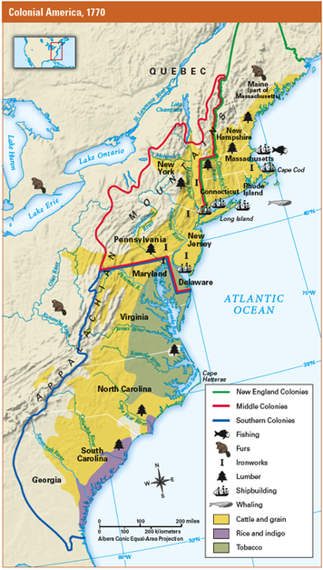
English settlers established colonies in North America for many reasons. Some colonies were set up by groups of businesspeople who hoped to profit from resources found in the Americas. Several colonies were settled by people looking for a place to practice their religion freely. One colony was established as a refuge for debtors (people who owe money), who would otherwise have been tossed into prison.
The English government supported all these efforts in part because it was competing for land in the Americas with such nations as France and Spain. England had another reason for establishing colonies: it was also competing for wealth. Like most western European nations in the late 1600s, England followed an economic policy that is called mercantilism. Under this policy, nations tried to gain wealth by controlling trade and establishing colonies. The colonies made money for England by supplying raw materials for its industries. England turned the raw materials into goods that it could sell to other nations and to its own colonies.
By 1733, there were 13 British colonies strung along the Atlantic coastline. They can be grouped into three distinct regions: the New England, Middle, and Southern Colonies. These regions had different climates and resources that encouraged settlers to develop different ways of life.

The New England Colonies The New England region included the colonies of Massachusetts, Rhode Island, Connecticut, and New Hampshire. As you will read, the first settlers of these colonies came to America seeking religious freedom.
In New England, farming was difficult because of the long, cold winters and the region's rocky, hilly wilderness. But the forests and the sea provided useful resources and ways to make a living. New Englanders built their economy on small farms, lumbering, fishing, shipbuilding, and trade.

The Middle Colonies The four Middle Colonies were New York, Pennsylvania, New Jersey, and Delaware. The landscape of this region ranged from the rich soil of coastal New Jersey and Delaware to the valleys and wooded mountains of New York and Pennsylvania. Farmers in the Middle Colonies raised a variety of crops and livestock. Lumbering, shipbuilding, and other occupations added to the many opportunities here.
The people who settled the Middle Colonies represented many cultures and religions. One important group, the Quakers, started the colony of Pennsylvania. Like the early settlers of New England, the Quakers were looking for freedom to practice their religion. Others seeking religious freedom soon followed. Settlements of French, Dutch, Germans, Swedes, Danes, Finns, Scots, Irish, and English spread throughout the Middle Colonies.
The Southern Colonies The five Southern Colonies were Maryland, Virginia, North Carolina, South Carolina, and Georgia. This region featured broad rivers and vast wetlands that gradually merged with the sea. The soil and the hot, wet climate were ideal for growing tobacco, rice, and other cash crops.
Wealthy colonists took advantage of these conditions by establishing large farms called plantations. Plantation owners relied on indentured servants and enslaved Africans to sow and harvest their fields. After being harvested, the crops could be brought by river to the coast and loaded on ships for transport to other colonies and to Europe.
Government in the Colonies All the colonies were settled with the permission of the king of England. For each colony, the king issued a charter, a formal document that outlined the colony's geographic boundaries and specified how it would be governed. Because the colonies were so far from England, however, they needed to be able to make their own laws and keep peace and order.
The colonies developed different forms of government, depending on the settlement's purpose. Most of the colonies were self-governing. Colonists elected members of their community to a general assembly, which made their laws.
Many colonies also had a governor appointed by the king. As the king's representative, the governor could overrule the elected assembly. Some colonies also had councils, groups of men who represented the English businessmen involved in starting the colony.
In Massachusetts, religious colonists established a theocracy, a government whose leaders ruled in the name of God. In time, however, a system of town meetings evolved in which colonists voted for representatives to govern them.
In many ways, the colonies were more democratic than England. Still, not all colonists had a voice in the government. Usually, only free, white, landowning men were allowed to vote. In some colonies, voters also had to belong to the preferred church. Other colonists including women, servants, slaves, and skilled tradesmen who were not landowners had no voting rights.

